You can use the Visual Studio build in replacement (Ctrl + H) with an activate regex search.

[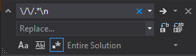](https://i.stack.imgur.com/fejP3.png)

As already shown in the image, use \/\/.*\n as expression and nothing as replacement. But as [@AakashM](https://stackoverflow.com/users/71059/aakashm) pointed out in the comments below: You have to be careful, because this regex also matches strings containing //.

If your inline comments are just single lines with /* some comment */ you can use \/\*.*\*\/.

And for matching single and multiline comments /* */ you can use \/\*(.*?\n?)*\*\/.